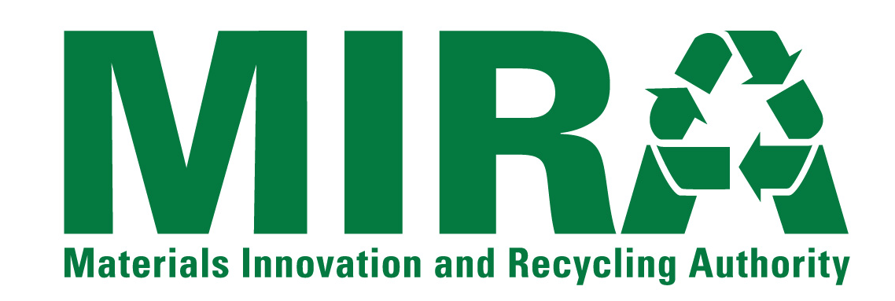
NOTICE OF INTEREST FORM
Individuals and firms that have an interest in the Materials Innovation and Recycling Authority (“MIRA”) solicitation listed below are encouraged to submit this Notice Of Interest Form to MIRA as early as they can. Request For Bids/Proposals/ Qualifications documents and other information released by MIRA related to the solicitation will be directly provided to those firms that have submitted this Form to MIRA.
Solicitation: | HUMAN RESOURCES CONSULTING SERVICES
RFQ Number: | RFQ 15-HR-001
Provide the following information about the individual/firm and the contact person for the firm.
Name of Individual/Firm:
Name of Contact Person:
Title of Contact Person:
Mailing Address 1:
Mailing Address 2:
City, State, Zip Code
Telephone Number:
Fax Number:
E-Mail Address:
Submit this form to the MIRA contact listed below via e-mail, fax or correspondence as listed below.
MIRA Contact: | Roger Guzowski
E-Mail Address: | rguzowski@ctmira.org
Fax Number: | (860) 757-7742
Correspondence Address: | Materials Innovation and Recycling Authority  100 Constitution Plaza, 6th Floor  Hartford, CT 06103

